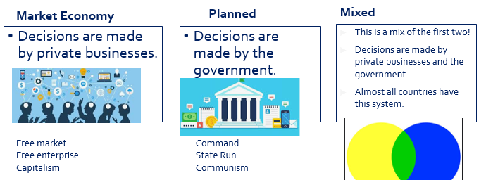
Unit 1
1.1 Scarcity
Resources
What is scarcity
4 types of resource: Land labor capital enterprise
Resources are used to satisfy our wants
limited resources, unlimited wants
The fundamental economic problem
Macroeconomics vs Microeconomics
Market Economy, Planned Economy, Mixed Economy
Incentives
Positive = can be right or wrong eg. Dogs can fly = wrong. Dogs have 4 legs = right
Normative = opinion that can’t be proven right or wrong. eg. Dogs are amazing.
Positive vs Normative economics

1.2 Opportunity Cost, PPC
Next best opportunity foregone when we make a decision
Opportunity cost definition
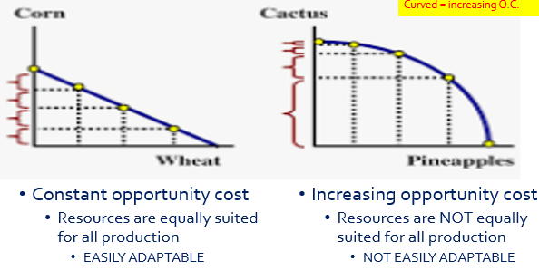
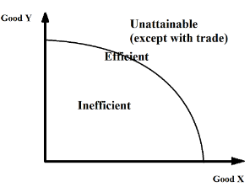
The PPC
Graphical Representation
Tradeoffs / Opportunity Cost
Why only two goods?
Efficient, inefficient, unattainable
Pareto Improvement
Efficient in production vs efficient in allocation
Increasing vs constant opportunity cost
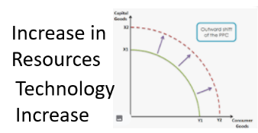
Shifting the PPC
1.3 Comparative Advantage and Gains from Trade
Adam Smith said that countries should specialize in what they have absolute advantage in.
David Ricardo said that they should really specialize in what they have comparative advantage in.
Specialization and Adam Smith
Abs Adv: who can produce more
Compar Adv. = lower Opportunity Cost

Absolute Advantage
Comparative Advantage (David Ricardo)
Gains from trade
Can consume outside of PPC, without changing the PPC at all.
Input Based Questions:
eg. labor hours, electricity used, resources used, capital used
Abs Adv: the smaller number
Comp adv: Reverse the OC calculation

Output Based Questions:
OC, Opportunity Cost = what you give up / what you gain = the ‘other good’ / the good you are looking at.

How to do these questions
Output based
Input based
Terms of trade
1.4 Demand
The benefit that people receive from something.
Higher Utility = You will pay a higher price (willingness to pay)
Utility
All buyers and sellers together.
What is a market
Shows the relationship between price and quantity demanded by consumers.
A demand schedule
Negative relationship between price and quantity.

Law of Demand
Income effect, substitution effect, diminishing marginal utility

Three reasons for slope of demand
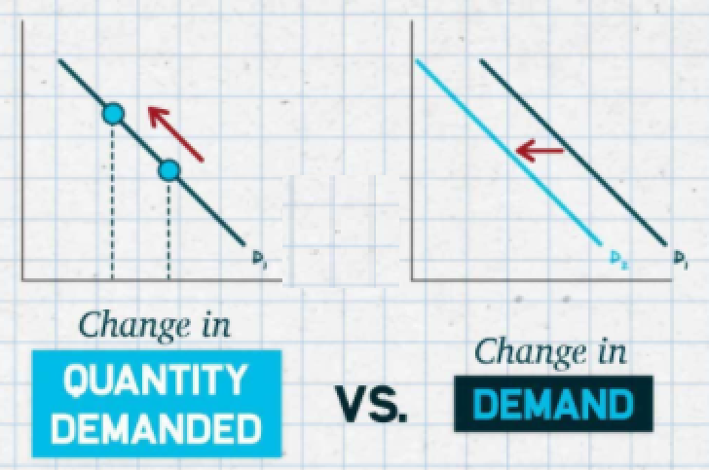
Two ways to look at demand
Shifters/Determinants of demand
1.5 Supply
Positive relationship between price and quantity.

Law of supply
Two ways to look at supply
Shifters/Determinants of supply
1.6 Market Equilibrium, Disequilibrium and Changes in Equilibrium
Shortage/Surplus
Change in Equilibrium
Double Shift Rule
Double Shift Rule: If both demand and supply shift, either price or quantity will be indeterminate.

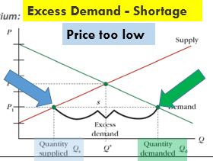
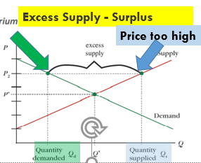

Unit 2

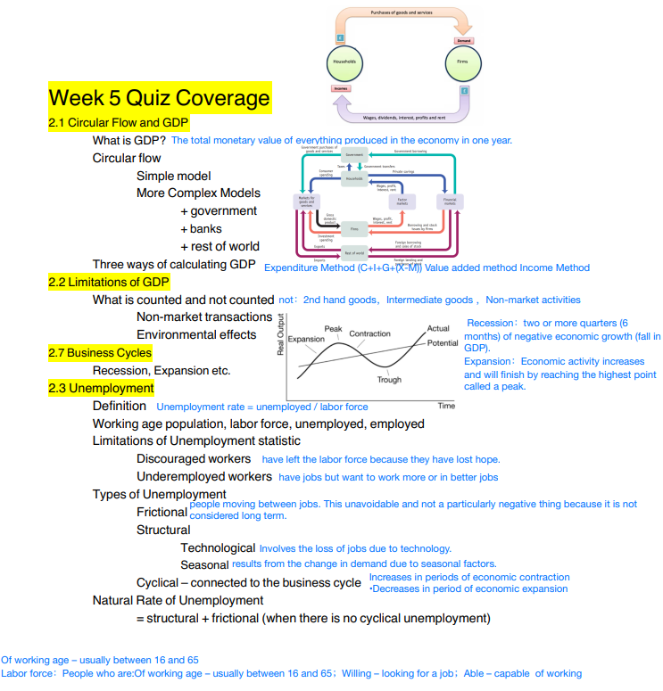
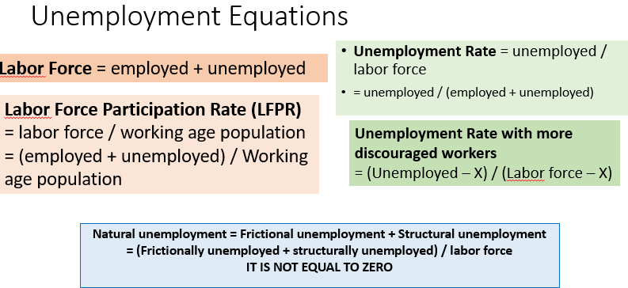
2.4 Price Indices and Inflation
price level (price of all goods and services) increases, value of money decreases
What is inflation?
Market Basket_{new} / Market Basket_{baseyear} x 100
CPI
Changes to quality of goods (CPI overestimates inflation), Substituting for other goods (overstates), changes to basket (over/understates)
Problems with CPI
GDP Deflator
Shoe Leather: Having to change money to other assets – time and effort
Menu: Having to change listed prices on menus, billboards etc.
2.5 Costs of Inflation
Menu Costs, Shoe Leather Costs
Unit of account – using money to measure the value of things
Wages lose value, savings lose value, loss of unit of account
Fisher Equation: Real interest = Nominal interest - inflation
Borrowers gain, lenders lose
2.6 Real v. Nominal GDP
Real = adjusted for inflation
Real = Adjusted for Inflation, Old Prices x quantity
Nominal = not adjusted for inflation, New Prices x quantity

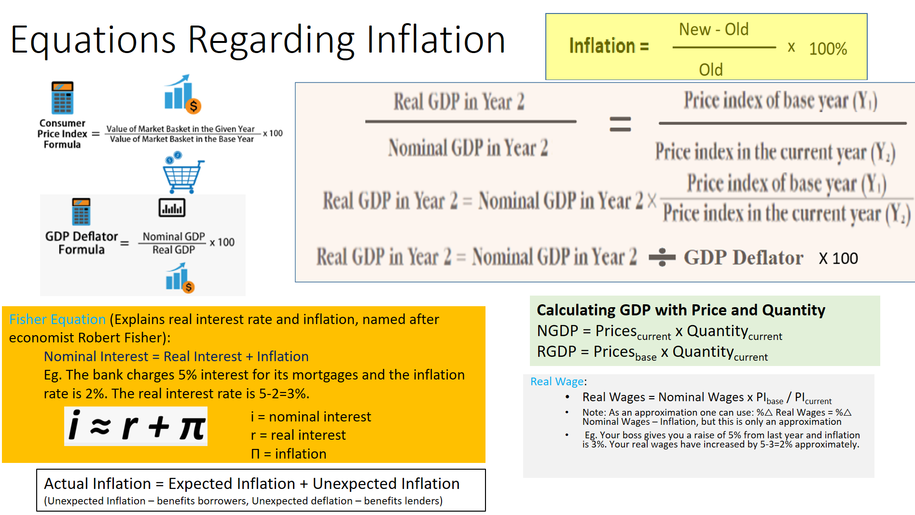
2.7 Business Cycles
Recession, Expansion etc.
Output Gaps
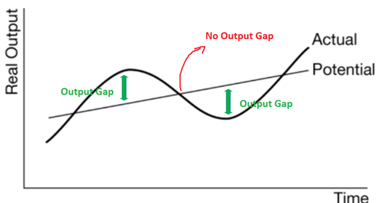
Unemployment
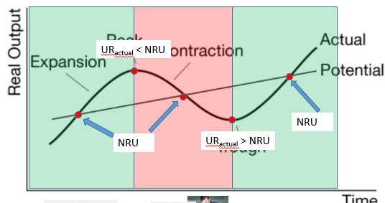

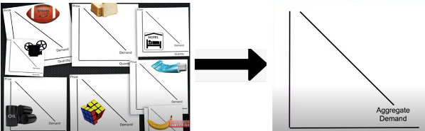
Unit 3
3.1 Aggregate Demand (AD)
Axes are different: P → PL, Aggregate Price Level
Q → Real GDP, Real Output, Y
All market demand curves added together
Three reasons why it slopes down
1. Interest Rate Effect 2. Wealth Effect 3. Foreign Trade Effect
Sticky wages/resource costs – prices don’t change because of contracts, mental resistance, efficiency wages
C+I+G+(X-M)
3.3 Short-Run Aggregate Supply (SRAS)
upward slope = +ve r’ship between PL and Output. Wages stay the same even when selling price of products changes, so profits/output increases/decreases
Shifters of SRAS / Short Run Supply Shocks
Sticky wages – causes upward slope
3.4 Long-Run Aggregate Supply (LRAS)
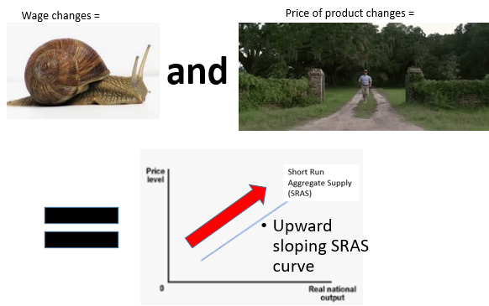
Shifters of LRAS / Long Run Supply Shocks
Connection to the Macroeconomy – PPC, Trend Line Growth
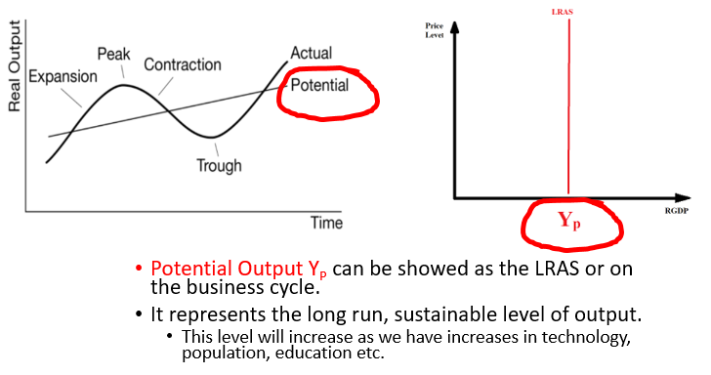
LRAS moves to right:
permanent increase in technology or productivity or resources
3.5 Equilibrium in the Aggregate Demand–Aggregate Supply (AD–AS) Model
AD=SRAS=LRAS
Long Run Macroeconomic Equilibrium
3.6 Changes in the AD–AS Model in the Short Run
AD=SRAS
Short Run Macroeconomic Equilibrium
Output Gaps
Negative – Recessionary Gap, Deflationary Gap, Stagflation (SRAS decreases)
Positive – Inflationary Gap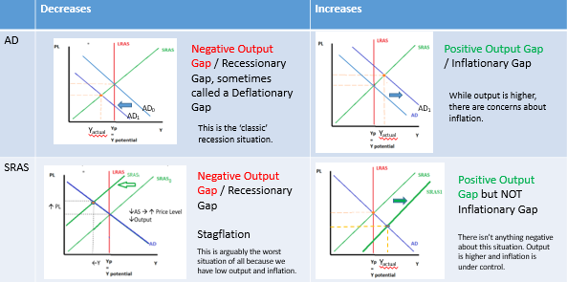

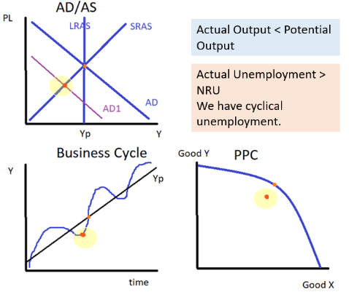
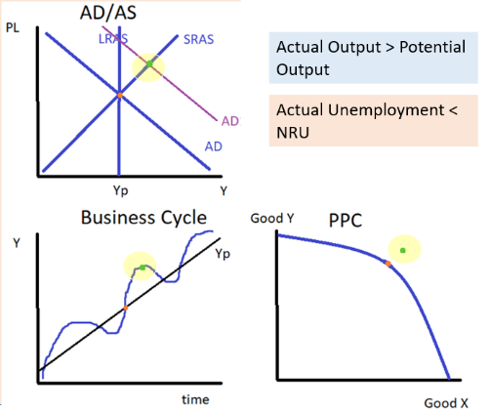
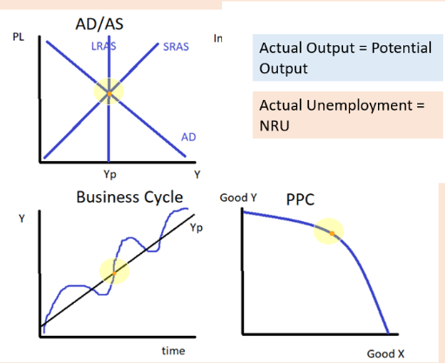

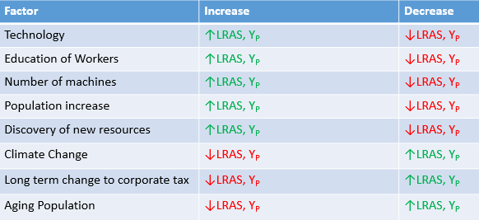
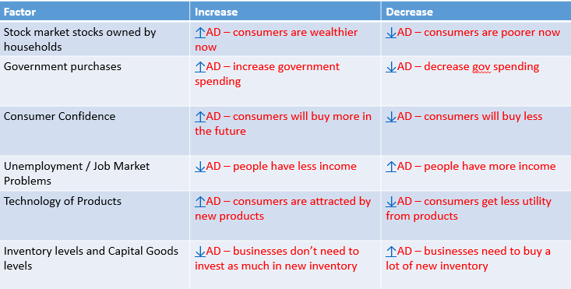

Negative Output Gap Self Adjustment
Positive Output Gap Self Adjustment

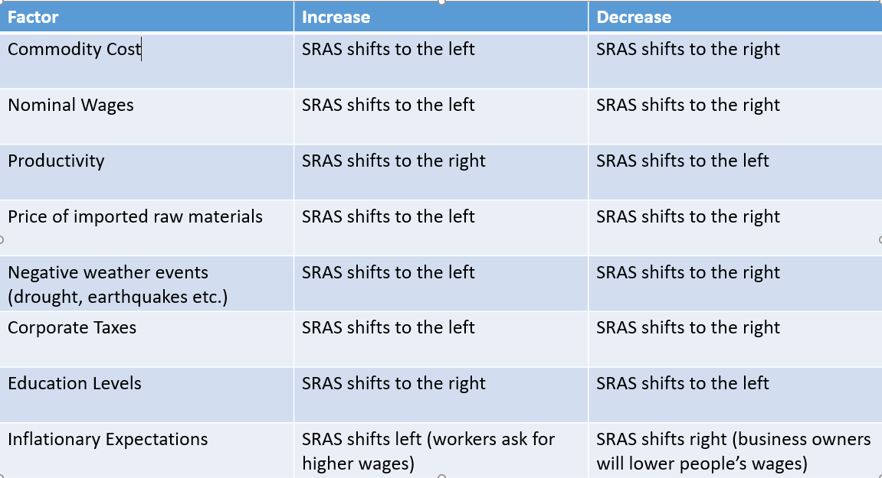
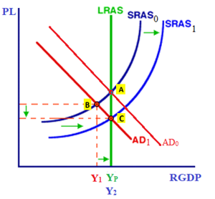
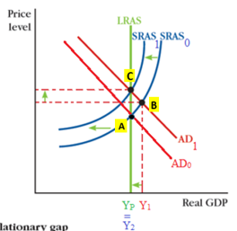

3.7 Long-Run Self-Adjustment
SRAS Shifts due to resource costs becoming flexible in long run, to return economy to Y_{P}
Long Run Self Adjustment
Classical – economy self adjusts naturally
Keynesian – economy self adjusts but often takes too long so gov should intervene
Classical Economic Thinking vs Keynesian Thinking
3.8 Fiscal Policy (FP)
FP Tools
Gov spending
Gov transfers
Tax
Expansionary – ↑AD, to fight a recession/negative output gap
↑Gov spending ↑Gov transfers ↓Tax
Contractionary - ↓AD, to fight inflation/positive output gap
↓Gov spending ↓Gov transfers ↑Tax
Fiscal Policy – expansionary vs contractionary
Historical context: John Maynard Keynes
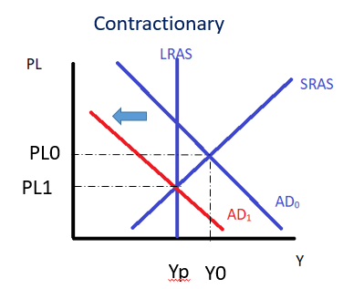
Fiscal Lag – Data Lags, Political Lags, Implementation Lags
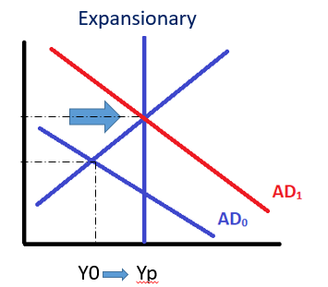
Keynesian Aggregate Supply Curve
Horizontal section has ‘space capacity’ (unused resources).
Keynes believed this shape meant Fiscal Policy could help the economy a lot when in a recession without causing inflation.
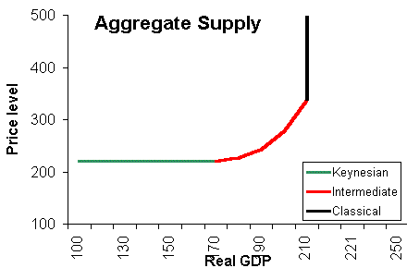
Fiscal Lag
Data lags – economic data takes time to collect and analyse, so information is not completely up to date
Political lags – political disagreement and decision making takes time
Implementation lags – fiscal spending projects such as building infrastructure, or military spending are not immediate

3.9 Automatic Stabilizers
Discretionary Fiscal Policy (human decision) vs. Non-discretionary fiscal policy (tax and social security)
Two Types of Fiscal Policy

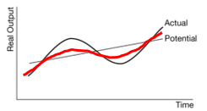
Effect on the business cycle
Discretionary Fiscal Policy/Automatic Stabilizers = tax, social security payments
Recession: ↓Tax ↑Social Security →↑AD
Inflationary Gap: ↑Tax ↓Social Security →↓AD
Reduces size of Output Gaps

Discretionary Fiscal Policy = human decisions are made to spend on things such as Infrastructure, Education, Military
The Automatic Stabilizers will ‘smooth’ the business cycle so that the recessions and expansions are less.

3.2 Multipliers
MPC = Marginal Propensity to Consume
MPS = Marginal Propensity to Save
MPS+MPC = 1
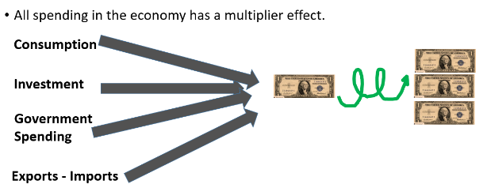
MPC, MPS, Multiplier= 1/MPS = 1/(1-MPC)
Tax Multiplier = -MPC/(1-MPC)
Transfer Multiplier = MPC/(1-MPC)
Full Multiplier: MPC + MPS + MPT (pay tax) + MPM (buy imports)
Spending Multiplier > Tax Multiplier
Therefore, equal size change to tax vs gov spending creates an ↑AD
Most important Equations for Multipliers:
∆GDP = ∆Spending x Multiplier
∆GDP = ∆Tax x Tax Multiplier
∆GDP = ∆transfers x transfer multiplier

